**ECE4612/5612 –Advanced Processor Systems**

**Final Project**

**Due: 12/06/2018 by 5:00 via email**

Each student is required to do a final project which weighs 25% of your final grade. The project goal is to use Verilog (Xilinx ISE Design) to implement a single-cycled processor based on the block diagram in Figure 1. The processor should be able to execute load, store, R-type (addition, subtraction, division, multiplication, and 3 logic operations of your choice), branch, and jump instructions.

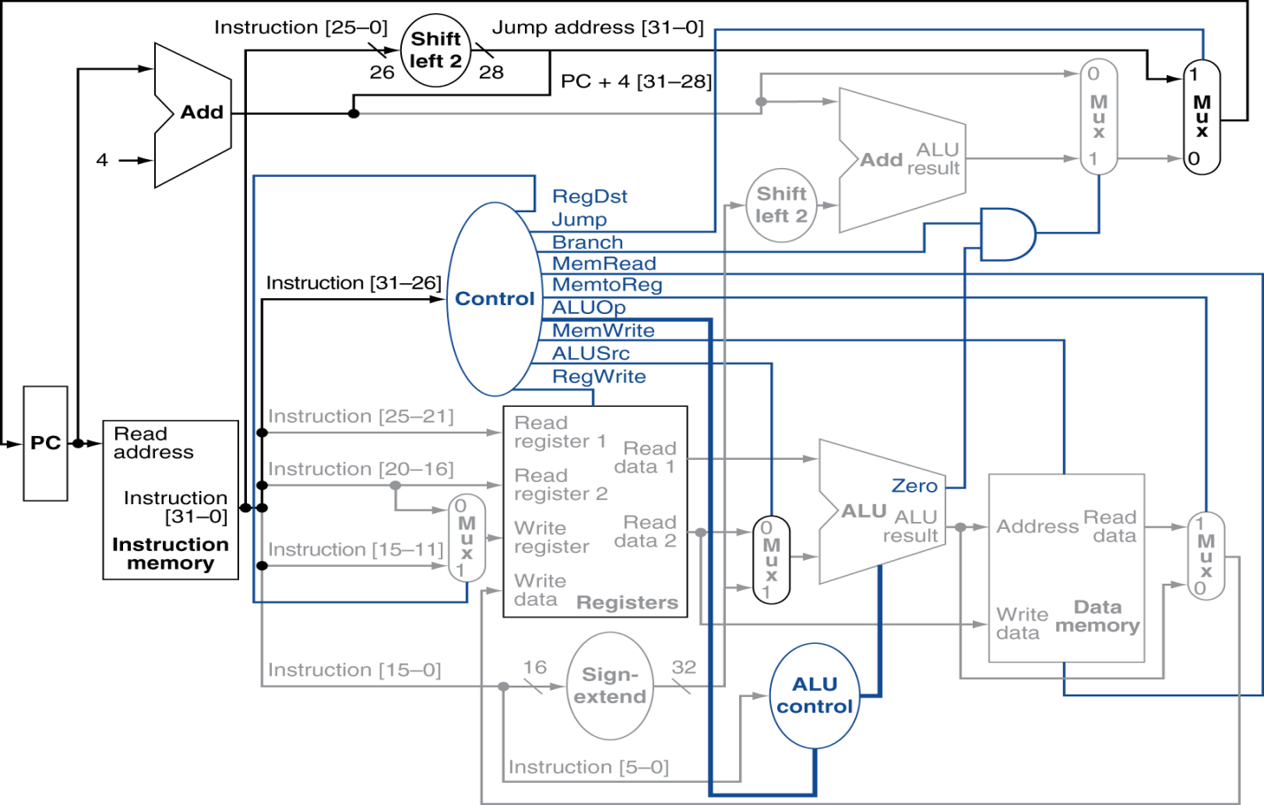

Figure 1: Block diagram of a simplified single-cycled processor.

Note:

* The adder of the ALU needs to be designed using structural model, and built from bottom up, i.e., from half adder > 1-bit > 4-bit > 16-bit > 32-bit
* For multiplier and divider, you should specify which algorithm/flowchart will be used in your project, and you design the unit accordingly
* For other modules like logical unit, shifter, sign extension … you can do behavioral modeling
* Every single module in your design needs to be tested, and you should include all the simulation waveform with explanations in your report
* For every single module in the block diagram in Figure 1, you should include a description of the inputs, output(s) and the functionality of the module

Although the deadline for the project is 12/13/2017, every week, you are supposed to email the instructor your design and simulation of the module(s) you propose the week before. **If you do not submit your weekly design and simulation but the entire working processor in the week of the deadline, you can only get a maximum of 90% for the project.**

Your weekly and final project report should include:

1. Cover page:
2. Objective(s)
3. Tools/equipment/software
4. Procedure
5. Test plan
6. Results/observations
7. Conclusion

By December 1st , each student will be emailed an expression to test your overall design. Your simulation results should show step-by-step execution of the instructions generated to evaluate the given expression.